Deep Breathing, Coughing, and Moving After Abdominal Surgery
​​​​It’s important to practice deep breathing and coughing so that you’ll be able to do the exercises below easily after surgery. If you’ve been given an incentive spirometer (IS) also practice using it. These exercises will help your breathing, clear your lungs, and lower your risk of pneumonia.
Breathe deeply and cough every hour while you’re awake for the first 2 to 3 days after minor surgery, and until the pain in your incision is gone after you’ve had major surgery. These exercises work better if you do them sitting up.
It’s also important to move and change your position often. These position changes help to make your breathing and coughing exercises work better.

Deep Breathing Exercises
Do these exercises every hour when you’re awake.
- 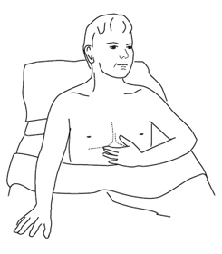Breathe in deeply and slowly through your nose, expanding your lower rib cage, and letting your abdomen move forward.
- Hold for a count of 3 to 5.
- Breathe out slowly and completely through pursed lips. Don’t force your breath out.
- Rest and repeat 10 times every hour. Rest longer if you become dizzy or lightheaded.

How to Use an Incentive Spirometer (IS)
If you’ve been given an incentive spirometer, use it every hour while you’re awake. The instructions below are for the Voldyne® spirometer. If you have a different type of incentive spirometer, please read the manufacturer’s instructions.
- 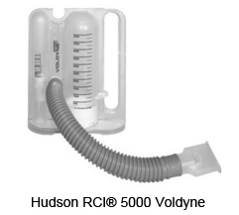a) Hold the IS upright.
b) Breathe out normally.
c) Place your lips tightly around the mouth piece, making a firm seal.
- Breathe in slowly, raising the white piston as high as possible while keeping the yellow float between the blue lines.
- Hold your breath for a count of 3 to 5.
- Take out the mouthpiece and breathe out slowly. (The white piston should fall to the bottom of the chamber.)
- Rest and repeat 10 times every hour. Rest longer if you become dizzy or light-headed.
*As you use the IS more often, move the yellow slider on the side of the unit to the highest level you can reach. Try to reach this level with each breath, always remembering to breathe in slowly.

Coughing Exercises
Coughing exercises are best done when you’re feeling comfortable. Your healthcare provider will tell you if you shouldn’t do the coughing exercises below.
- 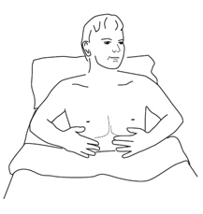If you’re lying on your back, bend your knees (if your surgeon says you can), and rest your feet on the bed.
- Depending on the surgery you had, support your incision firmly with your hands or a small pillow before you try to cough.
- Breathe in deeply and cough firmly. If you cough up some mucous, clear it into a tissue. Repeat the coughing until there isn’t any more mucous. If you have a lot of mucous you may need to take a break so you don’t get too tired.

Foot and Leg Exercises
Foot and leg exercises, also help you to get better sooner and prevent problems like blood clots. You may also have SCD stockings (Sequential Compression Devices) on your legs (the stockings inflate and deflate to keep good blood flow in your legs).
Do these exercises every hour while you’re awake.

A. Ankle Pump
- Pump your ankles up and down for 1 minute.
- Relax both feet.
- Repeat 5 times then relax.
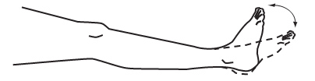

B. Ankle Circles
- Circle both ankles; first to the right, and then to the left.
- Repeat 5 times then relax.
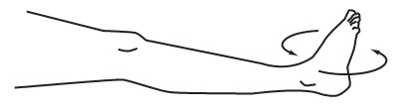
If your surgeon says you can:
- Bend each knee one at a time, sliding your foot up along the bed and then back down.
- Repeat 5 times then relax.

Changing Positions
Change your position every hour while awake, or as directed by your nurse. It’s important to move often to prevent problems like a lung infection, blood clots, and weak muscles.

To Turn onto Your Side
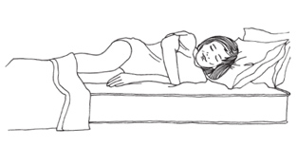
- If your surgeon says you can, bend both knees, placing your feet firmly on the bed.
- Roll onto your side, keeping yourself in a straight line.
- Hold on to the bed rail (if there is one) to finish the turn.
Call your nurse if you need help.

To Turn Back Again
- If your surgeon says you can, bend both knees.
- Push your hand into the bed to help you turn onto your back.

Sitting on the Side of the Bed
Once you’re allowed to get up:
- 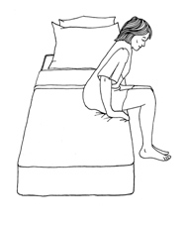Raise the head of the bed or ask someone to raise it for you.
- If your surgeon says you can, bend both knees, placing your feet firmly on the bed.
- Roll onto your side, keeping yourself in a straight line. Your bent knees should be close to the edge of the bed.
- Lower your legs down over the side of the bed as you sit up.
- Push with your upper hand down into the mattress until you have your lower elbow underneath you. Rest on this elbow.
- Push down on your arms until both arms are straight.
- Sit on the edge of the bed with hands on the mattress for support.

Getting Back into Bed
- 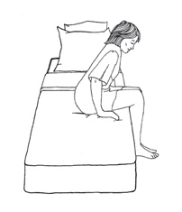Back up until you feel the bed at the back of your legs. Make sure you’re far enough up the bed towards the pillow.
- Sit down with your bottom as far back on the bed as possible.
- Lower yourself onto the elbow closest to the head of the bed.
- Lift your legs onto the bed as you go down onto your side.
- Lower your head onto the pillow while staying on your side. Use your hand as a support.
- Bend your knees and roll back onto your back.
- If you need to move higher up in the bed, keep your knees bent and push down on your heels. Lift your hips at the same time and move yourself up toward your pillows.

Walking
- For your safety, it’s important to have a nurse or physical therapist with you the first time you get up, and remember to wear proper footwear.
- At first you may need some help. As you become stronger, you’ll be able to move around more on your own. You may need to take short rests in between walks.
- It’s normal to feel dizzy and uncomfortable when you first get up. Remember to move slowly. If you have more pain or dizziness, please tell your nurse or physical therapist.
- The goal is to be able to walk in the hall several times a day.
If you have any questions about these exercises, please ask your physical therapist or nurse.

